**TECHNICAL UNIVERSITY OF CLUJ-NAPOCA**

Faculty of Electronics, Telecommunications and Information Technology

MATLAB SEMESTER PROJECT

**Temporal Extreme Two-Port DC Networks**

**Supervisors: Student:**

Conf. Dr. Ing. Mihaela Cirlugea Muresan Mihai

Prof. Farago Paul Group 2023

Table of contents

I.INTRODUCTION . 3

1. A short prologue 3

2.Matlab 4

II. DETAILED DESCPRIPTION 5

• The Temporal Extreme Two-Port DC Networks 5

III. EXPERIMENTAL RESULTS 7

1.The interface in Matlab 7

2.The calculation for the Positive/Negative Peak Detectors 8

3.The Charts for the Detectors 9

IV.REFERENCES 10

## 

## I.INTRODUCTION .

## 1. A short prologue

A temporal extreme two-port network is a type of electronic circuit that exhibits extreme behavior in response to temporal variations. In simpler terms, it's a network that demonstrates unique characteristics during specific time intervals. In this context, the circuit is designed to capture extreme values or peaks during certain periods of the input signal, both in positive and negative directions.

Purpose:

Temporal extreme two-port networks find applications in signal processing, communications, and various electronic systems where capturing extreme values or peaks in time-domain signals is crucial.

Features:

Positive Peak Detector: Captures the highest positive value in a signal.

Negative Peak Detector: Captures the lowest negative value in a signal.

Capacitor Charging Simulation: Models the behavior of a capacitor during specific time intervals.

# 

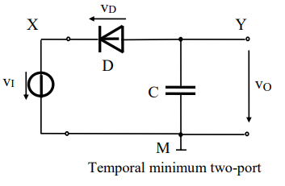

## 2.Matlab

*Definition:*

MATLAB, short for MATrix LABoratory, is a high-performance programming language and numerical computing environment used extensively in engineering, science, and mathematics. It provides a platform for algorithm development, data analysis, visualization, and numerical computation.

*History:*

MATLAB was created by Cleve Moler in the late 1970s at the University of New Mexico. Initially developed to facilitate matrix computation, it quickly evolved into a powerful tool for engineers and scientists. MathWorks, founded by Moler, played a significant role in the development and commercialization of MATLAB.

*Syntax:*

MATLAB's syntax is designed to be intuitive and expressive, making it easy to translate mathematical ideas into code. Key features include:

Matrix Operations: MATLAB excels at matrix and vector operations.

Built-in Functions: A rich set of built-in functions for mathematical operations, signal processing, image processing, and more.

Plotting: MATLAB provides powerful tools for 2D and 3D plotting and visualization.

Scripting: MATLAB supports both script and function-based programming.

## II. DETAILED DESCPRIPTION

## The Temporal Extreme Two-Port DC Networks

Now, let's delve deeper into the characteristics and analysis of two-port networks:

Characteristics of Two-Port Networks:

Linearity: Two-port networks are linear systems, meaning that they follow the principles of superposition and homogeneity.

Time-Invariance: The properties of a two-port network do not change with time.

Reciprocity: The response of the network remains the same when the input and output terminals are interchanged.

Parameters of Two-Port Networks:

Z-Parameters (Impedance Parameters): Describe the relationship between voltage and current at both input and output terminals.

Y-Parameters (Admittance Parameters): Represent the conductance and admittance between input and output terminals.

H-Parameters (Hybrid Parameters): Combine elements of both Z and Y parameters and are useful in certain applications.

ABCD-Parameters (Transmission or Chain Parameters): Characterize the relationship between voltage and current waves in a transmission line.

Applications of Two-Port Networks:

Signal Processing: Used in the design of amplifiers, filters, and signal processing systems.

Communication Systems: Employed in the analysis of communication channels, impedance matching, and signal transmission.

Control Systems: Essential for modeling and analyzing feedback systems in control engineering.

Understanding two-port networks is crucial for electrical engineers as it forms the basis for analyzing and designing various electronic systems.

## 

## III. EXPERIMENTAL RESULTS

This section of the project covers the simulations of the Temporal Extreme Two Port Networks (Positive Peak and Negative Peak detectors) in Matlab.

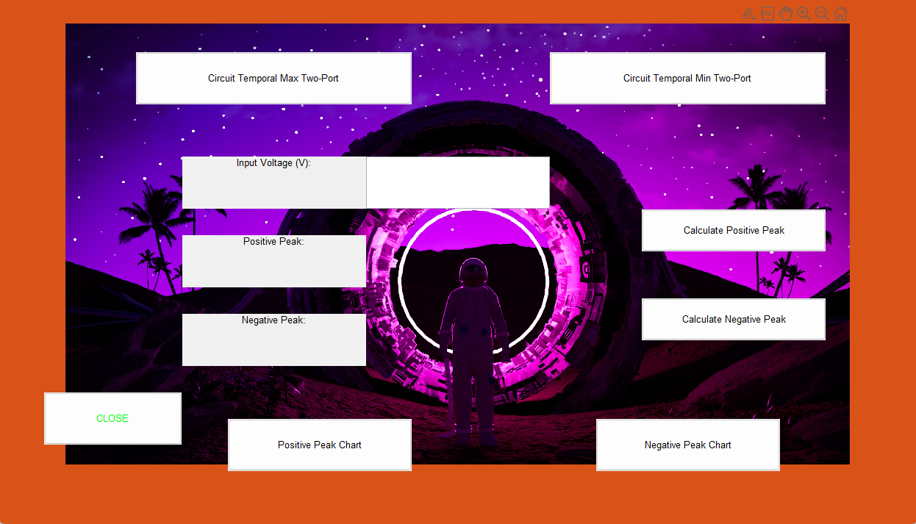

## 1.The interface in Matlab

It contains:

* 7 push buttons:
* Circuit for the Temporal Max/Min Two-Port
* Buttons for computing the Positive/Negative Peak
* Positive/Negative Peak charts
* Close button
* A label and edit field for the input voltage
* A menu that has:
* Documentatie
* Front Page

## 2.The calculation for the Positive/Negative Peak Detectors

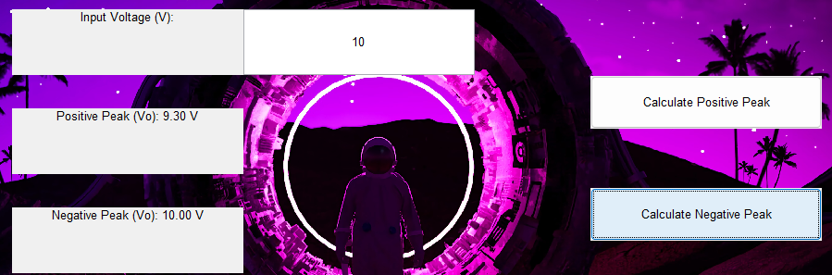

## 3.The Charts for the Detectors

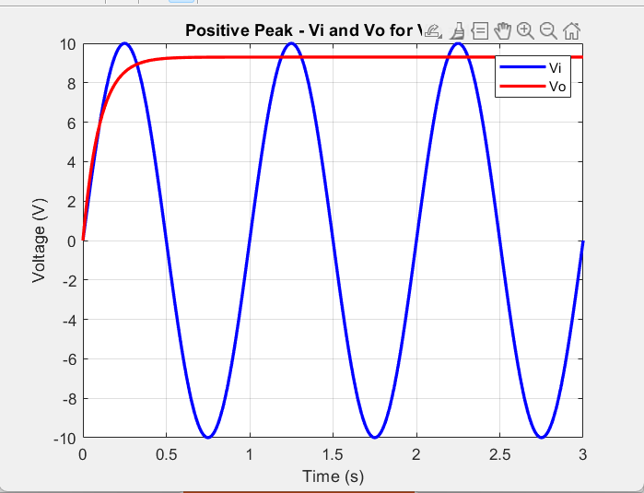

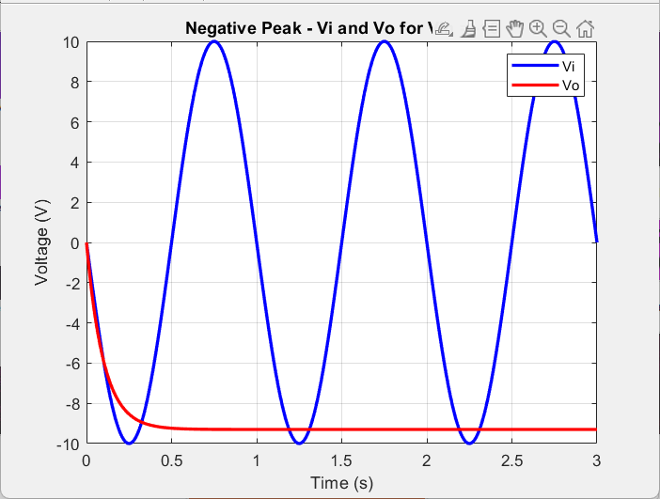

## IV.REFERENCES

<http://www.bel.utcluj.ro/dce/didactic/ed/>

<https://electronicscoach.com/peak-detector.html>

<https://www.researchgate.net/figure/Positive-and-negative-peak-detector-circuits_fig10_336268955>

<https://en.wikipedia.org/wiki/Envelope_detector>